Project Planning Phase
Project Planning Template (Product Backlog, Sprint Planning, Stories, Story points)

Date | 28-11-2025
Name | Yakshagaraj A G
Project Name | Online Bookstore
Maximum Marks | 5 Marks

Product Backlog, Sprint Schedule, and Estimation (4 Marks)

Product Backlog & Sprint Schedule
Sprint | Functional Requirement (Epic) | User Story Number | User Story / Task | Story Points | Priority
Sprint-1 | User authentication | USN-1 | As a user, I can sign up and log in securely. | 3 | High
 |  | USN-2  USN-3 | As a user, I can reset my password.  As a user, I can browse books by category. | 2  2 | Medium  High
Sprint-2 | Book Search & Filters | USN-4  USN-5 | As a user, I can search for books by title, author, or genre  As a user, I can filter books (price, rating, genre) | 3  2 | High  Medium
Sprint-3 | Cart, Wishlist, and Reviews | USN-6  USN-7 | As a user, I can add books to my cart.  As a freelancer, I can browse and filter jobs. | 3 | High
 |  | USN-8  USN-8 | As a user, I can add books to my wishlist.  As a user, I can submit reviews for purchased books | 2  2 | Medium  Medium
Sprint-4 | Orders, Admin Panel & Inventory | USN-9 | As a user, I can place an order for the books in the cart | 3 | High
 |  | USN-10  USN-11 | As an admin, I can add/edit/delete books.  As an admin, I can update book stock levels | 3  2 | High  Medium

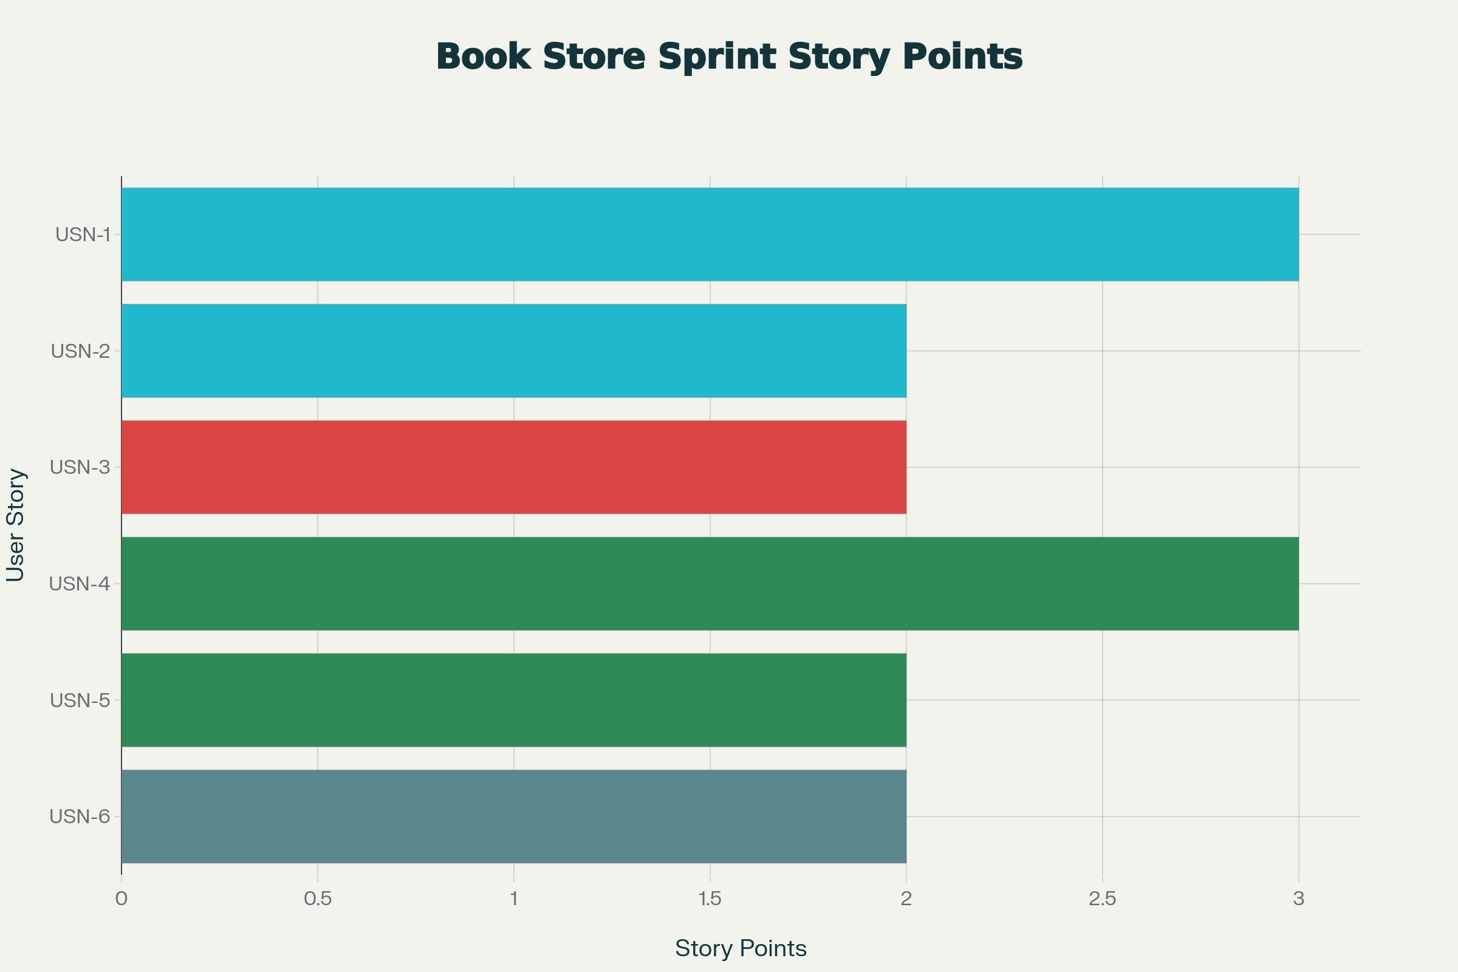
Project Tracker, Velocity & Burndown Chart

